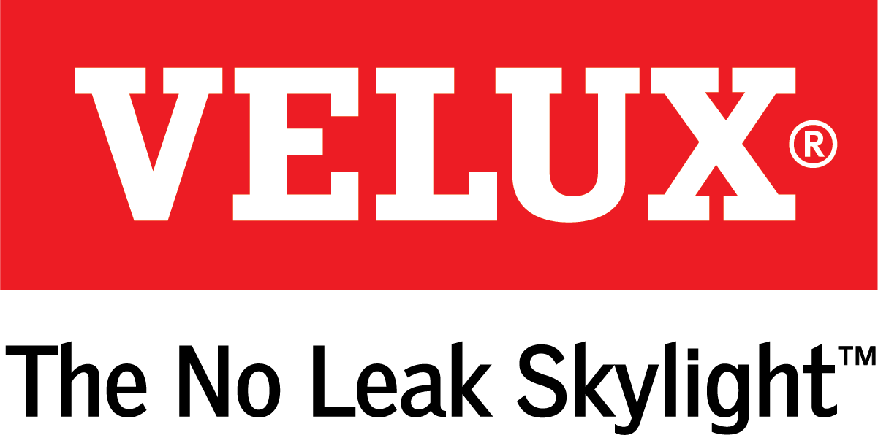
Media Contacts:
Kelsey Webb
704-790-1560
kwebb@wrayward.com

Dana Haydock
704-926-1301
dhaydock@wrayward.com

VELUX ROOF WINDOWS PROVIDE FRESH AIR AND NATURAL LIGHT IN EASY-TO-REACH SPACES
The Products Also Help Homeowners Comply with Building Codes

LAS VEGAS, Jan. 21-23, 2020 – VELUX offers roof windows for in-reach applications in both top and side-hinged options for attic and bonus room renovations. With easy maneuverability, roof windows also provide a point of egress, which helps with building codes compliance for two points of escape in case of fire.
“Roof windows offer convenient, practical options for homeowners who want easy roof access but also want to transform their space with natural light,” said Ross Vandermark, national product manager for VELUX America. “Plus, unique safety control features let homeowners rest assured they don’t have to sacrifice safety for fresh air ventilation.”
With convenient side or bottom handles for easy operation, homeowners can increase the amount of natural light and fresh air ventilation in their spaces, all while enjoying panoramic views. Plus, roof windows allow homeowners to rely less on electrical lighting, which helps to boost the home’s energy efficiency. VELUX also offers a variety of blind options for roof windows that give homeowners complete control over the amount of natural light they want in their rooms.
For more information on roof windows, visit veluxusa.com.

# # #

VELUX is the world leader in skylights and roof windows and is one of the strongest brands in the global building materials sector. VELUX products are available nationwide through home centers, building material suppliers, lumberyards and independent door, window or roofing retailers. Consumers can locate local suppliers and installers and access information on skylight selection and the benefits of bringing more natural light and fresh air into the home by visiting www.veluxusa.com or www.whyskylights.com. VELUX skylights are made in America in Greenwood, South Carolina.

